 | MEDIA RELEASE  DISTRICT OF COLDSTREAM  9901 Kalamalka Road  Coldstream, BC V1B 1L6
FOR IMMEDIATE RELEASE

DATE: May 30, 2025
MEDIA CONTACT: Janis Netzel
PHONE/EMAIL: 250-545-5304 / jnetzel@coldstream.ca

Sewer Works – Selkirk Drive Traffic Impacts

Sanitary sewer works associated with the Aberdeen Sanitary Sewer Project will be starting on Selkirk Drive. Traffic on Selkirk Drive, and at the intersection with Aberdeen Road, will be reduced to single alternating traffic starting on June 2, 2025 from 7 am to 7 pm, Monday to Friday, with potential for some weekend work.

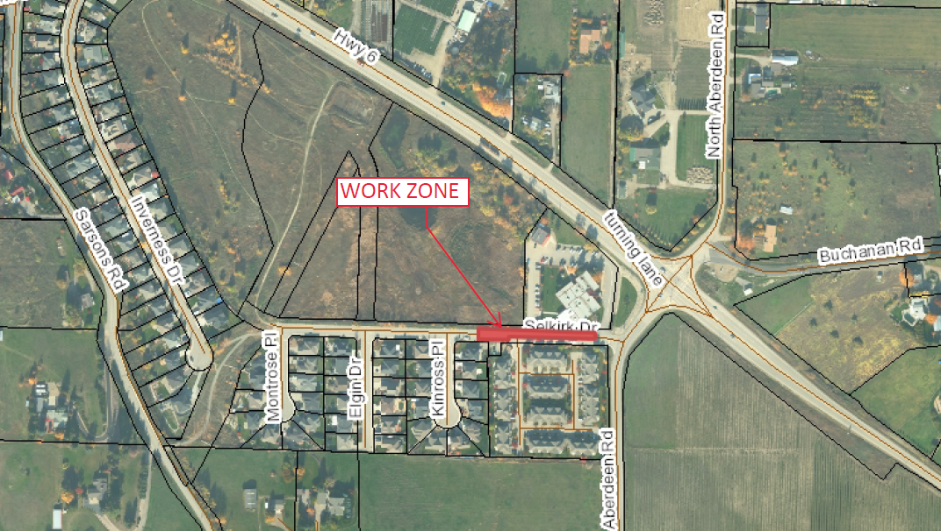

The works on Selkirk will extend through to June 30, 2025. Please obey all on-site traffic and construction personnel and use caution when driving through the work area.

Questions directly related to construction, such as schedule and traffic management, should be directed to Chapman Industries – 250-549-2907 (office) or to 250-550-6563 (Site Supervisor).

- ## -

